Vintage Edison Bulb

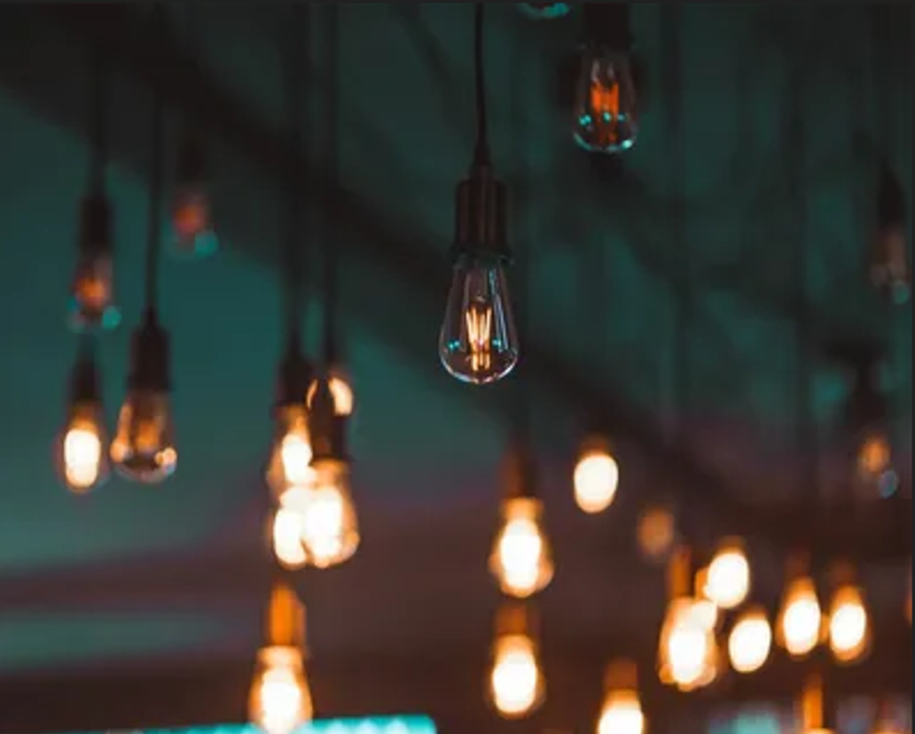

#### ****Description:****

**Vintage Edison Bulbs** are stylish, retro-inspired lighting solutions that combine the charm of old-world design with modern energy-efficient technology. These bulbs feature visible filaments and a warm, amber glow, making them perfect for creating a cozy and nostalgic ambiance in any space. Ideal for decorative lighting, Vintage Edison Bulbs are a popular choice for restaurants, cafes, living rooms, and more.

* **Technology:** LED or incandescent (depending on the model).
* **Compatibility:** Standard E26/E27 base (fits most fixtures).
* **Bulb Type:** ST64 (large globe shape), A19 (standard bulb shape).
* **Wattage:** 6W (LED, equivalent to 40W incandescent), 40W (incandescent).
* **Lumens:** 450 lumens (LED), 400 lumens (incandescent).
* **Color Temperature:** 2200K (warm amber glow).
* **Dimmable:** Yes (select models).
* **Lifespan:** 15,000 hours (LED), 1,000 hours (incandescent).
* **Energy Efficiency:** LED models are Energy Star certified.
* **Filament Design:** Visible filaments for a vintage look.

#### ****Key Features:****

* **Retro Design:** Visible filaments and amber glow for a nostalgic aesthetic.
* **Energy-Efficient (LED Models):** Uses up to 85% less energy than traditional incandescent bulbs.
* **Dimmable Options:** Available in dimmable models for adjustable brightness.
* **Versatile Use:** Perfect for decorative lighting in homes, restaurants, and cafes.
* **Warm Ambiance:** Creates a cozy and inviting atmosphere.
* **Long Lifespan (LED Models):** Lasts up to 15,000 hours, reducing the need for frequent replacements.

#### ****Pricing:****

* **Single Bulb (LED, ST64):** $14.99
* **Single Bulb (Incandescent, ST64):** $9.99
* **4-Pack (LED, ST64):** 49.99(49.99(12.50 per bulb)
* **4-Pack (Incandescent, ST64):** 34.99(34.99(8.75 per bulb)

#### ****Where to Use:****

* **Living Rooms:** Add a vintage touch to your decor.
* **Restaurants and Cafes:** Create a warm and inviting ambiance for customers.
* **Bedrooms:** Enhance relaxation with a cozy glow.
* **Patios:** Provide soft, decorative lighting for outdoor spaces.
* **Retail Stores:** Highlight vintage or rustic-themed products.

### ****Customer Reviews:****

* ⭐⭐⭐⭐⭐ "These Vintage Edison Bulbs are stunning! They add so much character to my living room. The warm glow is perfect for relaxing in the evenings." – Sarah L.
* ⭐⭐⭐⭐ "Great value for the price. The bulbs are beautiful, and the light is very warm and inviting. Highly recommend for anyone looking to add a vintage touch to their space." – James T.
* ⭐⭐⭐⭐⭐ "I love how energy-efficient the LED models are. The vintage design is a bonus!" – Emily R.

### ****How to Order:****

1. Visit our website: [www.brightworldlighting.com](http://www.brightworldlighting.com/)
2. Select your preferred bulb type and pack size (Single or 4-Pack).
3. Add to cart and proceed to checkout.
4. Enjoy free shipping on all orders over $50!

### ****Warranty and Support:****

* **Warranty:** 2-year limited warranty covering manufacturing defects (LED models).
* **Customer Support:** Contact us at [support@brightworldlighting.com](mailto:support@brightworldlighting.com) or call +1-800-123-4567 for assistance.

### ****Visual Representation:****

Include high-quality images of the Vintage Edison Bulbs in different settings (e.g., living room, cafe) to showcase their versatility and design.